Problem 1 : Driving a car

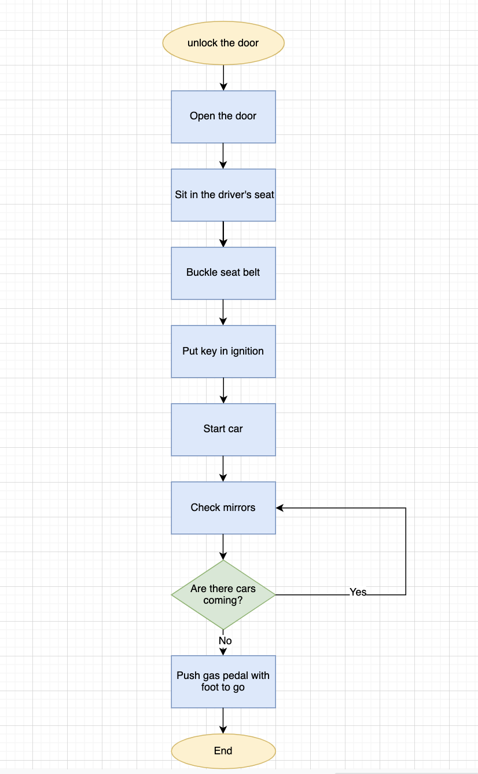

%3CmxGraphModel%3E%3Croot%3E%3CmxCell%20id%3D%220%22%2F%3E%3CmxCell%20id%3D%221%22%20parent%3D%220%22%2F%3E%3CmxCell%20id%3D%222%22%20style%3D%22edgeStyle%3DorthogonalEdgeStyle%3Brounded%3D0%3BorthogonalLoop%3D1%3BjettySize%3Dauto%3Bhtml%3D1%3BexitX%3D0.5%3BexitY%3D1%3BexitDx%3D0%3BexitDy%3D0%3B%22%20edge%3D%221%22%20source%3D%223%22%20target%3D%224%22%20parent%3D%221%22%3E%3CmxGeometry%20relative%3D%221%22%20as%3D%22geometry%22%3E%3CmxPoint%20x%3D%22340%22%20y%3D%22160%22%20as%3D%22targetPoint%22%2F%3E%3C%2FmxGeometry%3E%3C%2FmxCell%3E%3CmxCell%20id%3D%223%22%20value%3D%22unlock%20the%20door%22%20style%3D%22ellipse%3BwhiteSpace%3Dwrap%3Bhtml%3D1%3BfillColor%3D%23fff2cc%3BstrokeColor%3D%23d6b656%3B%22%20vertex%3D%221%22%20parent%3D%221%22%3E%3CmxGeometry%20x%3D%22270%22%20y%3D%2270%22%20width%3D%22140%22%20height%3D%2250%22%20as%3D%22geometry%22%2F%3E%3C%2FmxCell%3E%3CmxCell%20id%3D%224%22%20value%3D%22Open%20the%20door%22%20style%3D%22rounded%3D0%3BwhiteSpace%3Dwrap%3Bhtml%3D1%3BfillColor%3D%23dae8fc%3BstrokeColor%3D%236c8ebf%3B%22%20vertex%3D%221%22%20parent%3D%221%22%3E%3CmxGeometry%20x%3D%22280%22%20y%3D%22150%22%20width%3D%22120%22%20height%3D%2260%22%20as%3D%22geometry%22%2F%3E%3C%2FmxCell%3E%3CmxCell%20id%3D%225%22%20value%3D%22%22%20style%3D%22edgeStyle%3DorthogonalEdgeStyle%3Brounded%3D0%3BorthogonalLoop%3D1%3BjettySize%3Dauto%3Bhtml%3D1%3BfontSize%3D12%3B%22%20edge%3D%221%22%20source%3D%226%22%20target%3D%229%22%20parent%3D%221%22%3E%3CmxGeometry%20relative%3D%221%22%20as%3D%22geometry%22%2F%3E%3C%2FmxCell%3E%3CmxCell%20id%3D%226%22%20value%3D%22%26lt%3Bspan%26gt%3B%26amp%3Bnbsp%3BSit%20in%20the%20driver's%20seat%26lt%3B%2Fspan%26gt%3B%22%20style%3D%22rounded%3D0%3BwhiteSpace%3Dwrap%3Bhtml%3D1%3BfillColor%3D%23dae8fc%3BstrokeColor%3D%236c8ebf%3B%22%20vertex%3D%221%22%20parent%3D%221%22%3E%3CmxGeometry%20x%3D%22280%22%20y%3D%22240%22%20width%3D%22120%22%20height%3D%2260%22%20as%3D%22geometry%22%2F%3E%3C%2FmxCell%3E%3CmxCell%20id%3D%227%22%20style%3D%22edgeStyle%3DorthogonalEdgeStyle%3Brounded%3D0%3BorthogonalLoop%3D1%3BjettySize%3Dauto%3Bhtml%3D1%3BexitX%3D0.5%3BexitY%3D1%3BexitDx%3D0%3BexitDy%3D0%3B%22%20edge%3D%221%22%20parent%3D%221%22%3E%3CmxGeometry%20relative%3D%221%22%20as%3D%22geometry%22%3E%3CmxPoint%20x%3D%22339.5%22%20y%3D%22240%22%20as%3D%22targetPoint%22%2F%3E%3CmxPoint%20x%3D%22339.5%22%20y%3D%22210%22%20as%3D%22sourcePoint%22%2F%3E%3CArray%20as%3D%22points%22%3E%3CmxPoint%20x%3D%22339.5%22%20y%3D%22240%22%2F%3E%3CmxPoint%20x%3D%22339.5%22%20y%3D%22240%22%2F%3E%3C%2FArray%3E%3C%2FmxGeometry%3E%3C%2FmxCell%3E%3CmxCell%20id%3D%228%22%20style%3D%22edgeStyle%3DorthogonalEdgeStyle%3Brounded%3D0%3BorthogonalLoop%3D1%3BjettySize%3Dauto%3Bhtml%3D1%3BexitX%3D0.5%3BexitY%3D1%3BexitDx%3D0%3BexitDy%3D0%3B%22%20edge%3D%221%22%20parent%3D%221%22%3E%3CmxGeometry%20relative%3D%221%22%20as%3D%22geometry%22%3E%3CmxPoint%20x%3D%22339.5%22%20y%3D%22330%22%20as%3D%22targetPoint%22%2F%3E%3CmxPoint%20x%3D%22339.5%22%20y%3D%22300%22%20as%3D%22sourcePoint%22%2F%3E%3CArray%20as%3D%22points%22%3E%3CmxPoint%20x%3D%22340%22%20y%3D%22330%22%2F%3E%3CmxPoint%20x%3D%22340%22%20y%3D%22330%22%2F%3E%3C%2FArray%3E%3C%2FmxGeometry%3E%3C%2FmxCell%3E%3CmxCell%20id%3D%229%22%20value%3D%22Buckle%20seat%20belt%22%20style%3D%22rounded%3D0%3BwhiteSpace%3Dwrap%3Bhtml%3D1%3BfontSize%3D12%3BfillColor%3D%23dae8fc%3BstrokeColor%3D%236c8ebf%3B%22%20vertex%3D%221%22%20parent%3D%221%22%3E%3CmxGeometry%20x%3D%22280%22%20y%3D%22330%22%20width%3D%22120%22%20height%3D%2260%22%20as%3D%22geometry%22%2F%3E%3C%2FmxCell%3E%3CmxCell%20id%3D%2210%22%20style%3D%22edgeStyle%3DorthogonalEdgeStyle%3Brounded%3D0%3BorthogonalLoop%3D1%3BjettySize%3Dauto%3Bhtml%3D1%3BexitX%3D0.5%3BexitY%3D1%3BexitDx%3D0%3BexitDy%3D0%3B%22%20edge%3D%221%22%20parent%3D%221%22%3E%3CmxGeometry%20relative%3D%221%22%20as%3D%22geometry%22%3E%3CmxPoint%20x%3D%22339.5%22%20y%3D%22420%22%20as%3D%22targetPoint%22%2F%3E%3CmxPoint%20x%3D%22339.5%22%20y%3D%22390%22%20as%3D%22sourcePoint%22%2F%3E%3CArray%20as%3D%22points%22%3E%3CmxPoint%20x%3D%22340%22%20y%3D%22400%22%2F%3E%3CmxPoint%20x%3D%22340%22%20y%3D%22400%22%2F%3E%3C%2FArray%3E%3C%2FmxGeometry%3E%3C%2FmxCell%3E%3CmxCell%20id%3D%2211%22%20value%3D%22Put%20key%20in%20ignition%22%20style%3D%22rounded%3D0%3BwhiteSpace%3Dwrap%3Bhtml%3D1%3BfontSize%3D12%3BfillColor%3D%23dae8fc%3BstrokeColor%3D%236c8ebf%3B%22%20vertex%3D%221%22%20parent%3D%221%22%3E%3CmxGeometry%20x%3D%22280%22%20y%3D%22420%22%20width%3D%22120%22%20height%3D%2260%22%20as%3D%22geometry%22%2F%3E%3C%2FmxCell%3E%3CmxCell%20id%3D%2212%22%20style%3D%22edgeStyle%3DorthogonalEdgeStyle%3Brounded%3D0%3BorthogonalLoop%3D1%3BjettySize%3Dauto%3Bhtml%3D1%3BexitX%3D0.5%3BexitY%3D1%3BexitDx%3D0%3BexitDy%3D0%3B%22%20edge%3D%221%22%20parent%3D%221%22%3E%3CmxGeometry%20relative%3D%221%22%20as%3D%22geometry%22%3E%3CmxPoint%20x%3D%22340%22%20y%3D%22510%22%20as%3D%22targetPoint%22%2F%3E%3CmxPoint%20x%3D%22340%22%20y%3D%22480%22%20as%3D%22sourcePoint%22%2F%3E%3CArray%20as%3D%22points%22%3E%3CmxPoint%20x%3D%22340.5%22%20y%3D%22490%22%2F%3E%3CmxPoint%20x%3D%22340.5%22%20y%3D%22490%22%2F%3E%3C%2FArray%3E%3C%2FmxGeometry%3E%3C%2FmxCell%3E%3CmxCell%20id%3D%2213%22%20value%3D%22Start%20car%22%20style%3D%22rounded%3D0%3BwhiteSpace%3Dwrap%3Bhtml%3D1%3BfontSize%3D12%3BfillColor%3D%23dae8fc%3BstrokeColor%3D%236c8ebf%3B%22%20vertex%3D%221%22%20parent%3D%221%22%3E%3CmxGeometry%20x%3D%22280%22%20y%3D%22510%22%20width%3D%22120%22%20height%3D%2260%22%20as%3D%22geometry%22%2F%3E%3C%2FmxCell%3E%3CmxCell%20id%3D%2214%22%20style%3D%22edgeStyle%3DorthogonalEdgeStyle%3Brounded%3D0%3BorthogonalLoop%3D1%3BjettySize%3Dauto%3Bhtml%3D1%3BexitX%3D0.5%3BexitY%3D1%3BexitDx%3D0%3BexitDy%3D0%3B%22%20edge%3D%221%22%20parent%3D%221%22%3E%3CmxGeometry%20relative%3D%221%22%20as%3D%22geometry%22%3E%3CmxPoint%20x%3D%22339.5%22%20y%3D%22600%22%20as%3D%22targetPoint%22%2F%3E%3CmxPoint%20x%3D%22339.5%22%20y%3D%22570%22%20as%3D%22sourcePoint%22%2F%3E%3CArray%20as%3D%22points%22%3E%3CmxPoint%20x%3D%22340%22%20y%3D%22580%22%2F%3E%3CmxPoint%20x%3D%22340%22%20y%3D%22580%22%2F%3E%3C%2FArray%3E%3C%2FmxGeometry%3E%3C%2FmxCell%3E%3CmxCell%20id%3D%2215%22%20value%3D%22Check%20mirrors%22%20style%3D%22rounded%3D0%3BwhiteSpace%3Dwrap%3Bhtml%3D1%3BfontSize%3D12%3BfillColor%3D%23dae8fc%3BstrokeColor%3D%236c8ebf%3B%22%20vertex%3D%221%22%20parent%3D%221%22%3E%3CmxGeometry%20x%3D%22280%22%20y%3D%22600%22%20width%3D%22120%22%20height%3D%2260%22%20as%3D%22geometry%22%2F%3E%3C%2FmxCell%3E%3CmxCell%20id%3D%2216%22%20style%3D%22edgeStyle%3DorthogonalEdgeStyle%3Brounded%3D0%3BorthogonalLoop%3D1%3BjettySize%3Dauto%3Bhtml%3D1%3BexitX%3D0.5%3BexitY%3D1%3BexitDx%3D0%3BexitDy%3D0%3B%22%20edge%3D%221%22%20parent%3D%221%22%3E%3CmxGeometry%20relative%3D%221%22%20as%3D%22geometry%22%3E%3CmxPoint%20x%3D%22339.5%22%20y%3D%22690%22%20as%3D%22targetPoint%22%2F%3E%3CmxPoint%20x%3D%22339.5%22%20y%3D%22660%22%20as%3D%22sourcePoint%22%2F%3E%3CArray%20as%3D%22points%22%3E%3CmxPoint%20x%3D%22340%22%20y%3D%22670%22%2F%3E%3CmxPoint%20x%3D%22340%22%20y%3D%22670%22%2F%3E%3C%2FArray%3E%3C%2FmxGeometry%3E%3C%2FmxCell%3E%3CmxCell%20id%3D%2217%22%20value%3D%22Are%20there%20cars%20coming%3F%22%20style%3D%22rhombus%3BwhiteSpace%3Dwrap%3Bhtml%3D1%3BfontSize%3D12%3BfillColor%3D%23d5e8d4%3BstrokeColor%3D%2382b366%3B%22%20vertex%3D%221%22%20parent%3D%221%22%3E%3CmxGeometry%20x%3D%22280%22%20y%3D%22690%22%20width%3D%22120%22%20height%3D%2280%22%20as%3D%22geometry%22%2F%3E%3C%2FmxCell%3E%3CmxCell%20id%3D%2218%22%20style%3D%22edgeStyle%3DorthogonalEdgeStyle%3Brounded%3D0%3BorthogonalLoop%3D1%3BjettySize%3Dauto%3Bhtml%3D1%3BexitX%3D0.5%3BexitY%3D1%3BexitDx%3D0%3BexitDy%3D0%3B%22%20edge%3D%221%22%20parent%3D%221%22%3E%3CmxGeometry%20relative%3D%221%22%20as%3D%22geometry%22%3E%3CmxPoint%20x%3D%22339.5%22%20y%3D%22800%22%20as%3D%22targetPoint%22%2F%3E%3CmxPoint%20x%3D%22339.5%22%20y%3D%22770%22%20as%3D%22sourcePoint%22%2F%3E%3CArray%20as%3D%22points%22%3E%3CmxPoint%20x%3D%22340%22%20y%3D%22780%22%2F%3E%3CmxPoint%20x%3D%22340%22%20y%3D%22780%22%2F%3E%3C%2FArray%3E%3C%2FmxGeometry%3E%3C%2FmxCell%3E%3CmxCell%20id%3D%2219%22%20value%3D%22No%22%20style%3D%22text%3Bhtml%3D1%3BstrokeColor%3Dnone%3BfillColor%3Dnone%3Balign%3Dcenter%3BverticalAlign%3Dmiddle%3BwhiteSpace%3Dwrap%3Brounded%3D0%3BfontSize%3D12%3B%22%20vertex%3D%221%22%20parent%3D%221%22%3E%3CmxGeometry%20x%3D%22320%22%20y%3D%22770%22%20width%3D%2260%22%20height%3D%2230%22%20as%3D%22geometry%22%2F%3E%3C%2FmxCell%3E%3CmxCell%20id%3D%2220%22%20value%3D%22Push%20gas%20pedal%20with%20foot%20to%20go%22%20style%3D%22rounded%3D0%3BwhiteSpace%3Dwrap%3Bhtml%3D1%3BfontSize%3D12%3BfillColor%3D%23dae8fc%3BstrokeColor%3D%236c8ebf%3B%22%20vertex%3D%221%22%20parent%3D%221%22%3E%3CmxGeometry%20x%3D%22280%22%20y%3D%22800%22%20width%3D%22120%22%20height%3D%2260%22%20as%3D%22geometry%22%2F%3E%3C%2FmxCell%3E%3CmxCell%20id%3D%2221%22%20style%3D%22edgeStyle%3DorthogonalEdgeStyle%3Brounded%3D0%3BorthogonalLoop%3D1%3BjettySize%3Dauto%3Bhtml%3D1%3BexitX%3D0.5%3BexitY%3D1%3BexitDx%3D0%3BexitDy%3D0%3B%22%20edge%3D%221%22%20parent%3D%221%22%3E%3CmxGeometry%20relative%3D%221%22%20as%3D%22geometry%22%3E%3CmxPoint%20x%3D%22339.5%22%20y%3D%22890%22%20as%3D%22targetPoint%22%2F%3E%3CmxPoint%20x%3D%22339.5%22%20y%3D%22860%22%20as%3D%22sourcePoint%22%2F%3E%3CArray%20as%3D%22points%22%3E%3CmxPoint%20x%3D%22340%22%20y%3D%22870%22%2F%3E%3CmxPoint%20x%3D%22340%22%20y%3D%22870%22%2F%3E%3C%2FArray%3E%3C%2FmxGeometry%3E%3C%2FmxCell%3E%3CmxCell%20id%3D%2222%22%20value%3D%22End%22%20style%3D%22ellipse%3BwhiteSpace%3Dwrap%3Bhtml%3D1%3BfontSize%3D12%3BfillColor%3D%23fff2cc%3BstrokeColor%3D%23d6b656%3B%22%20vertex%3D%221%22%20parent%3D%221%22%3E%3CmxGeometry%20x%3D%22280%22%20y%3D%22890%22%20width%3D%22120%22%20height%3D%2240%22%20as%3D%22geometry%22%2F%3E%3C%2FmxCell%3E%3CmxCell%20id%3D%2223%22%20value%3D%22%22%20style%3D%22edgeStyle%3DsegmentEdgeStyle%3BendArrow%3Dclassic%3Bhtml%3D1%3Brounded%3D0%3BfontSize%3D12%3B%22%20edge%3D%221%22%20parent%3D%221%22%3E%3CmxGeometry%20width%3D%2250%22%20height%3D%2250%22%20relative%3D%221%22%20as%3D%22geometry%22%3E%3CmxPoint%20x%3D%22400%22%20y%3D%22730%22%20as%3D%22sourcePoint%22%2F%3E%3CmxPoint%20x%3D%22400%22%20y%3D%22630%22%20as%3D%22targetPoint%22%2F%3E%3CArray%20as%3D%22points%22%3E%3CmxPoint%20x%3D%22550%22%20y%3D%22730%22%2F%3E%3CmxPoint%20x%3D%22550%22%20y%3D%22630%22%2F%3E%3CmxPoint%20x%3D%22400%22%20y%3D%22630%22%2F%3E%3C%2FArray%3E%3C%2FmxGeometry%3E%3C%2FmxCell%3E%3CmxCell%20id%3D%2224%22%20value%3D%22Yes%22%20style%3D%22text%3Bhtml%3D1%3BstrokeColor%3Dnone%3BfillColor%3Dnone%3Balign%3Dcenter%3BverticalAlign%3Dmiddle%3BwhiteSpace%3Dwrap%3Brounded%3D0%3BfontSize%3D12%3B%22%20vertex%3D%221%22%20parent%3D%221%22%3E%3CmxGeometry%20x%3D%22440%22%20y%3D%22700%22%20width%3D%2270%22%20height%3D%2240%22%20as%3D%22geometry%22%2F%3E%3C%2FmxCell%3E%3C%2Froot%3E%3C%2FmxGraphModel%

Problem 2 : Even number

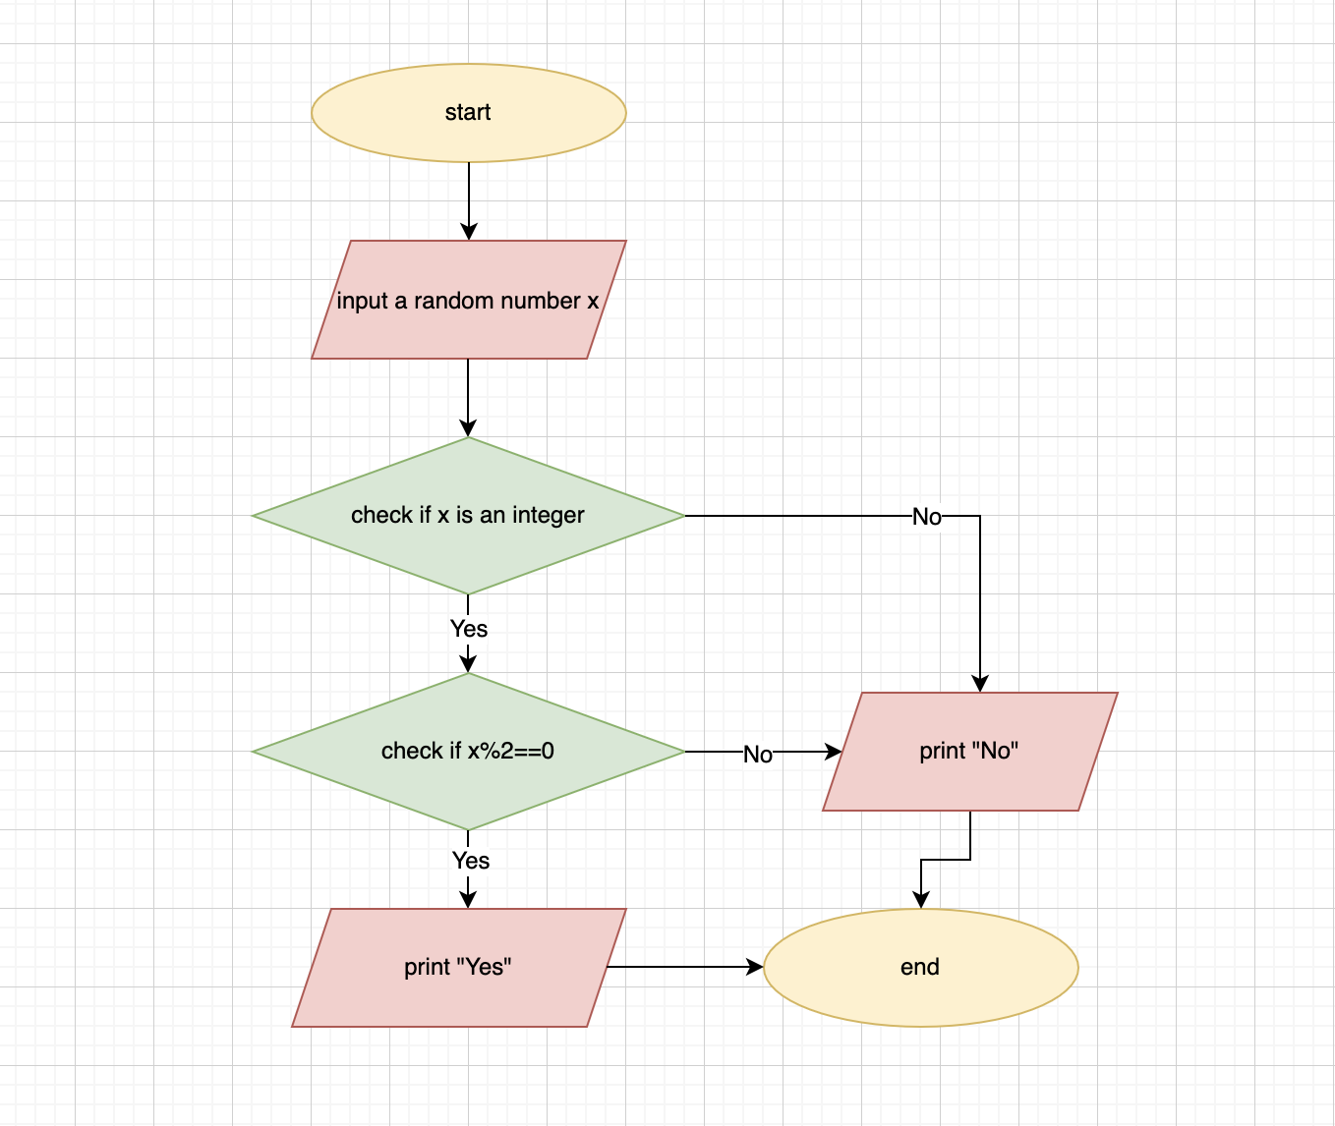

Problem 3 : Blackjack

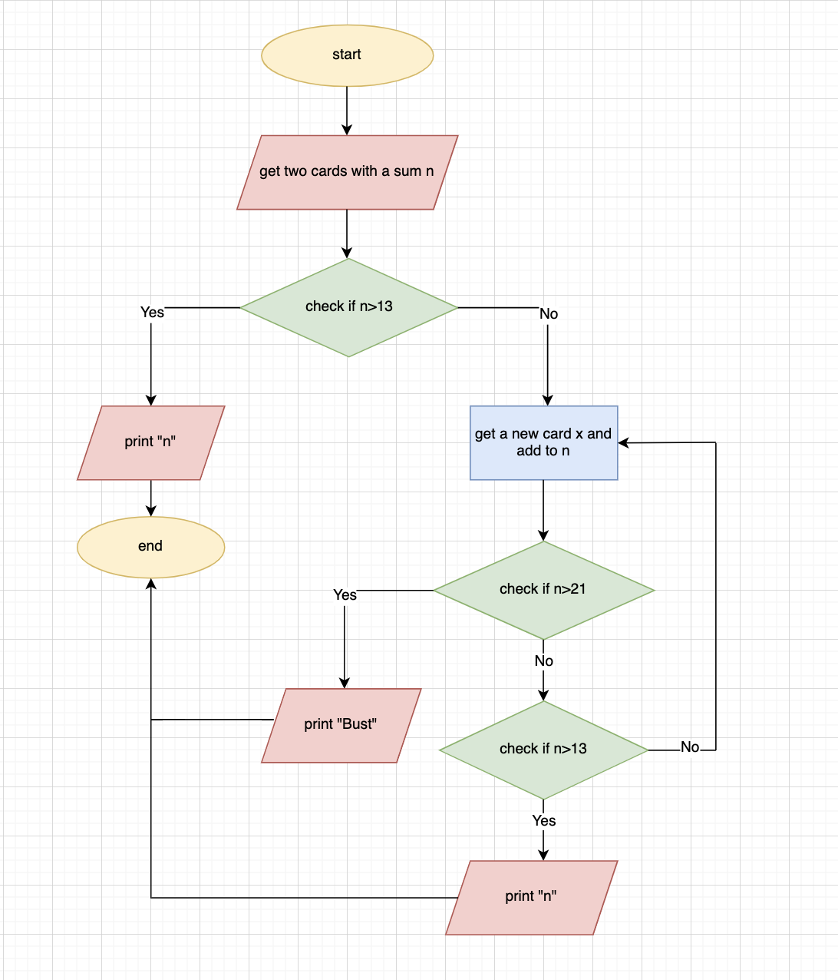

Problem 4

